Unit 1 | Excel Assignment | *Kickstart* My Chart

Background

While over ***2 billion dollars*** have been raised using the massively popular crowd-funding service, ***Kickstarter***, not all projects have been successful. Of the ***over 300,000 projects*** launched, only 1/3 make it through the entire process with a positive outcome.

Instructions

Using the Excel table provided, you will be modifying, organizing, and analyzing the data of [approximately] four thousand [exactly 4,114] ***Kickstarter*** projects as you attempt to uncover some of the market trends.

**Task.1 – Cell Color on *State Column Value***

*Use conditional formatting to fill each cell in the `state` column with a different color, depending on if the associated campaign was "successful," "failed," "cancelled," or is currently "live".*

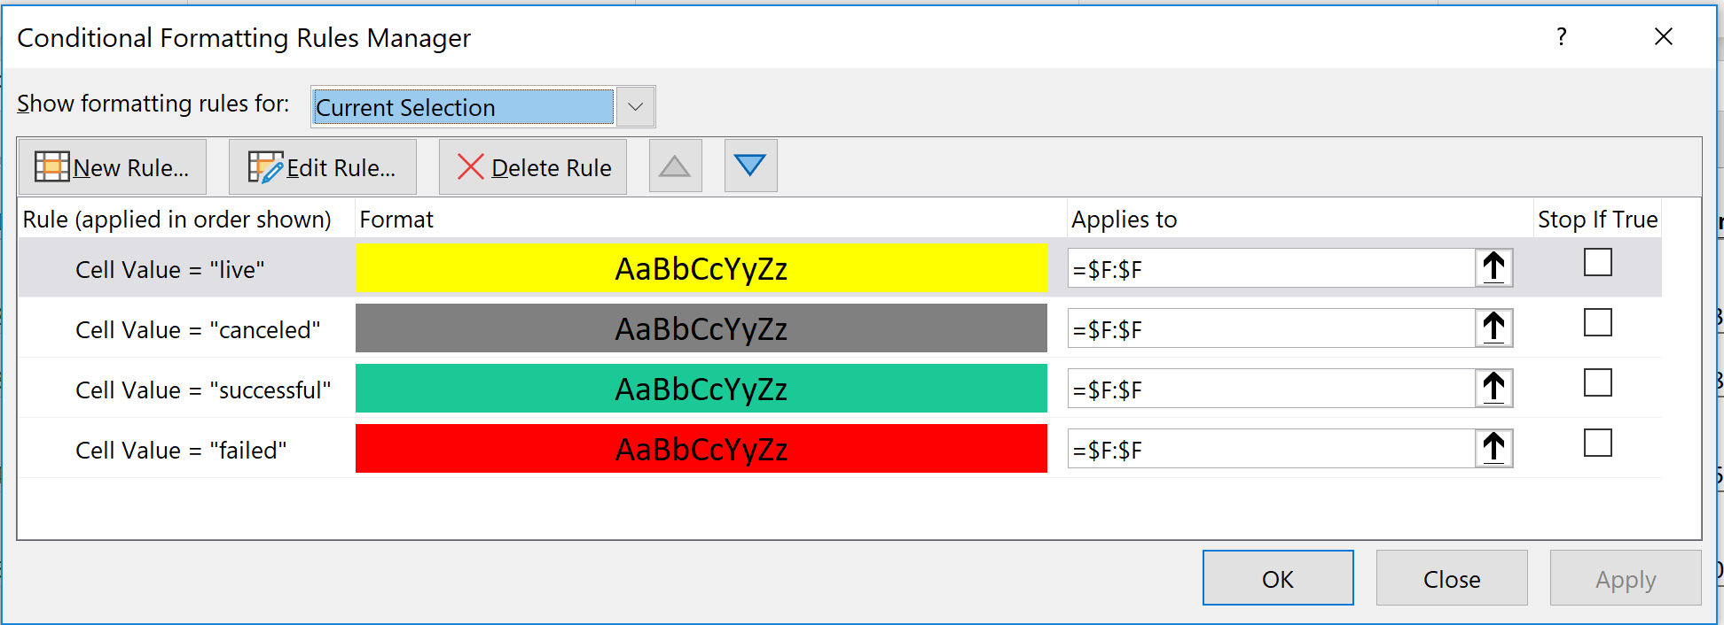

**<1> Task – Conditional Color Formatting Notes:**

* Took screenshot (above) of conditional format criteria
* Updated column heading from ‘State’ to ‘Project Status’ as it was clearer
* Project Status Analysis based on ‘State’ Column F
  + **Over half (53%) of projects were Successful (2185)**
    - All reached 100% or more of goal
    - Highest outlier raised **2260300%** of goal (highest 3 had goals = 1)
      * Research further – Can a *Kickstarter goal be anything? Why wouldn’t every project set a low goal so as to be deemed a “success”?*
  + **Over a third (37%) of projects Failed (1530)**
    - 7% of projects (287) failed without pledges
    - The remainder failed with pledges ranging from 1-205025
      * Research further – what causes a Kickstarter project to FAIL? Not meeting goal by deadline? Other reasons?
  + **8.5% of projects were Cancelled (349)**
    - 34% of projects (117) were cancelled without pledges
    - The remaining 66% (232) had pledge amounts ranging from 1-1076751.05 at the time of cancellation
  + **Just >1% of projects are Live or accepting pledges (50)**
    - * Research further – why would Live projects be included in a report analyzing end of project success? I would cut these out if I could.

**Task.2 – Column with *Percent Funded***

*Create a new column at column O called `percent funded` that uses a formula to uncover how much money a campaign made towards reaching its initial goal.*

**<2> Task - Percent Calculation Notes:**

* ***Percent Funded*** determined using the calculation of ***pledged*** divided by ***goal*** value (began with row 2, entering function =E2/D2, then pushed formula down to final row with =E4115/D4115)
* ***Percent Funded* analysis based on Column O data:**
  + **Field value 0.00**
    - 444 projects = <.01% or no pledges (goal not met)
  + **Field value 0.01-0.99**
    - 1506 projects = 1-99% (goal not met)
  + **Field value 1.00**
    - 196 projects = 100% (goal met)
  + **Field value 1.01-1.99**
    - 1939 projects = 101-199% (goal met)
  + **Field value greater than or equal to 2.00**
    - 259 projects = >200% (goal exceeded – pledges at least twice goal value)
* Formatted ***Percent Funded*** column first as a percent (flat), but, because Conditional Formatting in Task.3 would not allow 200% as the maximum “percent” value, so I changed the format back to numeric with four decimals (e.g. 1.0055) allowing for a percent up to two decimals (e.g. 100.55%)
  + Without decimals, a deceptive number of projects showed 0% for *Percent Funded*, which to me would indicate NO pledges, but many did in fact have pledges with a calculation of <1% of the goal
    - * Would clarify – to what decimal would they consider something 0 or 100%

**Task.3 – Color Scale on *Percent Funded***

*Use conditional formatting to fill each cell in the `percent funded` column using a three-color scale. The scale should start at 0 and be a dark shade of red, transitioning to green at 100, and then moving towards blue at 200.*

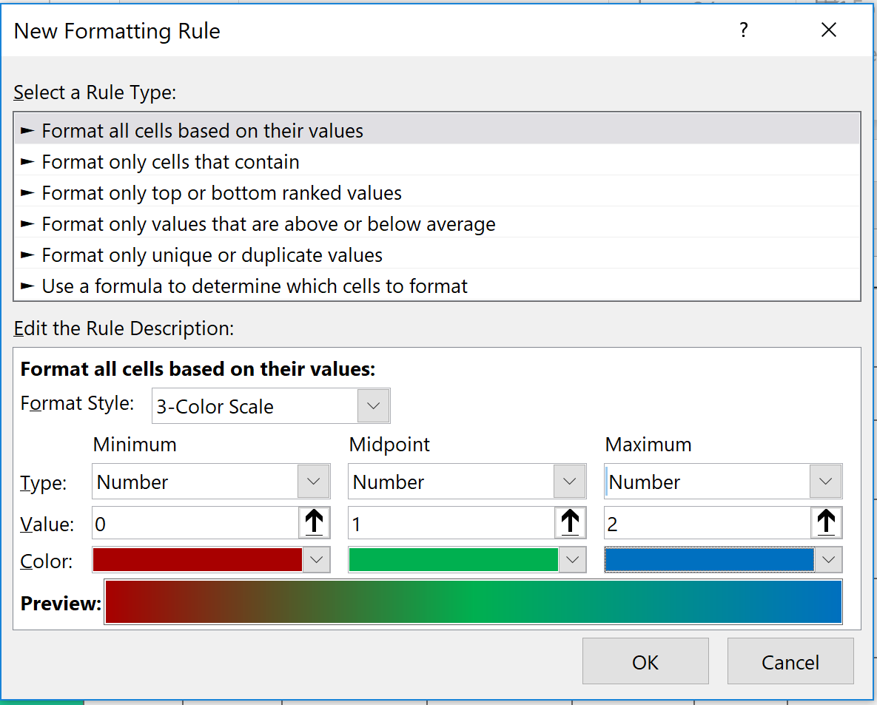

**<3> Task – Color Scale Notes:**

* Took screenshot (above) of conditional format criteria
* Conditional Formatting type = Color Scale, then “3 Color Scale”, Type ‘Number’
  + Min value = 0.0 (for 0%) set to **DARK RED**
  + Middle value = 1.0 (for 100%) set to **GREEN**
  + Max value = 2.0 (for 200%) set to **BLUE**
* As stated in Task.2, I originally tried using Type ‘Percent’, but learned that I couldn’t use the maximum of 200 as suggested here with that type. With *Percent Funded* formatted as a decimal value, 2.0 could represent 200%.
  + Reformatted column to percent after doing the Color Scale. After doing so, when I open the rule, it is cleared out, but the column is still scaled correctly. I’m sure this could have been done a number of different ways. (Picture below)

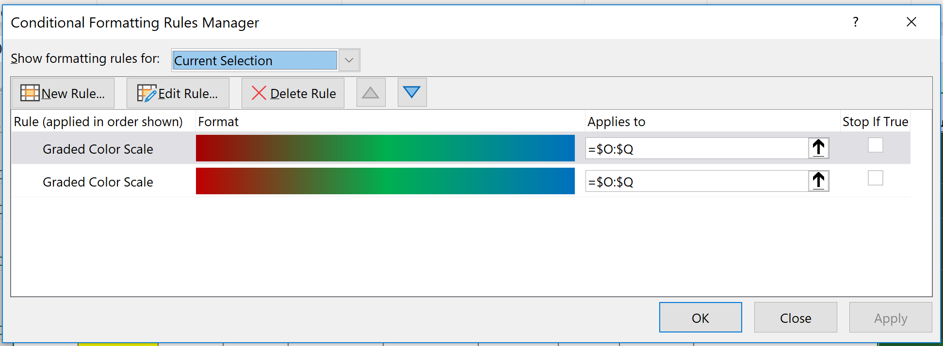

**Task.4 – Column with *Average Donation***

*Create a new column at column P called `average donation` that uses a formula to uncover how much each backer for the project paid on average.*

**<4> Task - Average Calculation Notes:**

* Named column ***Average Pledge*** rather than donation to match the language from column E where the funds are called pledges vs. donations
* Used calculation of ***Pledged Total*** divided by ***Backer Count*** value (began with row 2, entering function =E2/L2, then pushed formula down to final row with =E4115/L4115)
  + ***Average Pledge*** on projects range from **1.00** to **3304,** and there isn’t all that much variance based on the “outcome” or state of the project in termed of success, failure, or cancellation
    - Successful projects range from 3.25 – 2500.97
    - Failed projects range from 1.00 to 3000 (and 287 w/o pledges)
    - Canceled projects range from 1.00 to 3004 (and 117 w/o pledges)
  + 410 projects have calculation error **#DIV/0!** due to not having any pledges, but particularly no backers, causing a denominator of “0” to error.
    - Updated cell errors to N/A, as ‘not applicable’ it is more accurate representation of having no pledges at all

**Task.5 – Split Column *Category* & *Sub-Category***

*Create two new columns, one called `category` at Q and another called `sub-category` at R, which use formulas to split the `Category and Sub-Category` column into two parts.*

**<5> Task – Text Split to Columns Notes:**

* Used ***Convert Text to Columns*** wizard under ‘Data’ tab
  + Page 1 of 3 – Type ***Delimited***
  + Page 2 of 3 – Delimiter is type ***Other*** forward slash (/)
  + Page 3 of 3 – Data format ***General*** / Destination ***colQ*** and ***colR***

**Task.6 – Pivot Table Count *State* Column**

*Create a new sheet with a pivot table that will analyze your initial worksheet to count how many campaigns were "successful," "failed," "cancelled," or are currently "live" per **category**.*

**<6> Task – Notes and Table:**

* Took snap of Pivot Table, and here are the PivotTable Fields:
  + Project Name -> selected only
  + Project Status -> goes in Rows
  + Category -> goes in Rows
  + Project Count -> Goes in Values

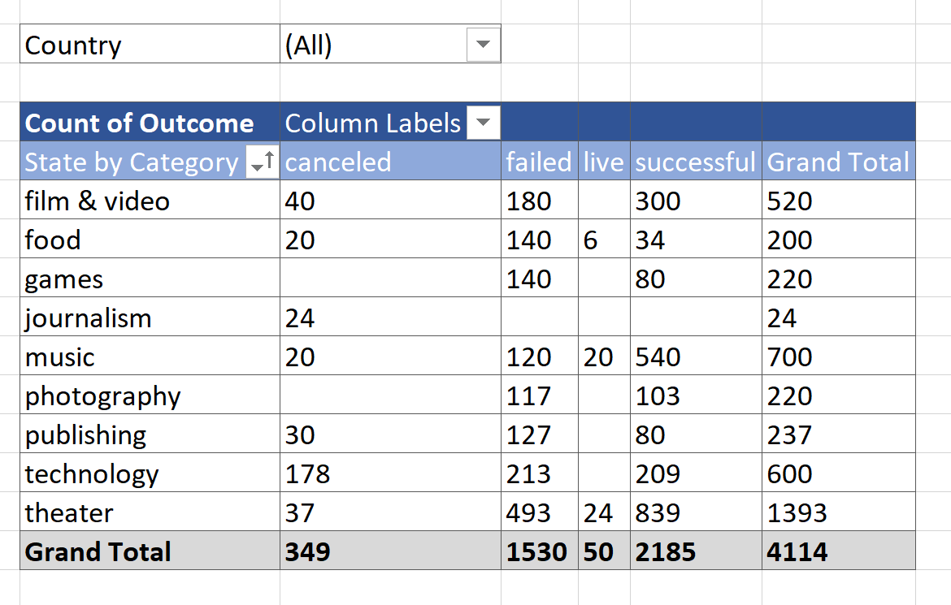

**Task.7 – Stacked Column Pivot Chart**

*Create a stacked column pivot chart that can be filtered by `country` based on the table you have created.*

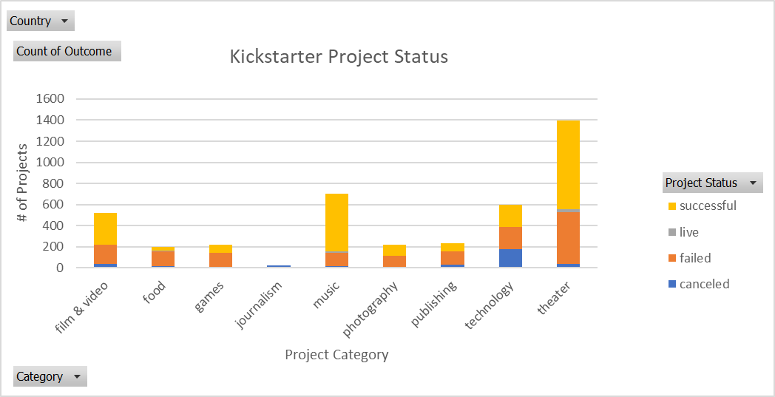

**Task.8 – Pivot Table**

*Create a new sheet with a pivot table that will analyze your initial sheet to count how many campaigns were "successful," "failed," "cancelled," or are currently "live" per **sub-category**.*

**<8> Task - Percent Calculation Notes:**

* Took screenshot (above) of conditional format criteria

**Task.9 – Pivot Table**

Create a stacked column pivot chart that can be filtered by `country` and `parent-category` based on the table you have created.

**<9> Task – Table and Stacked Chart Pictures:**

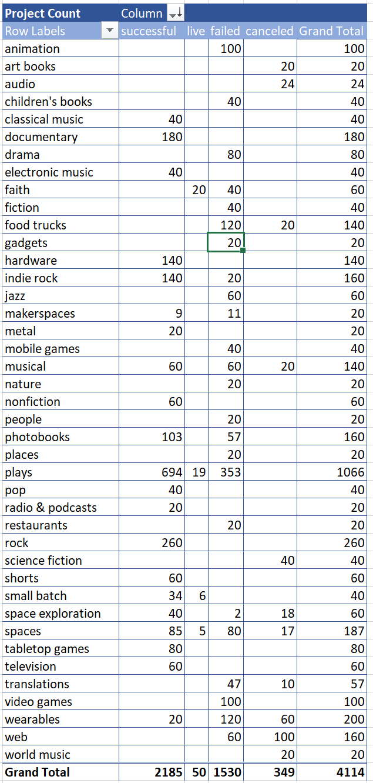

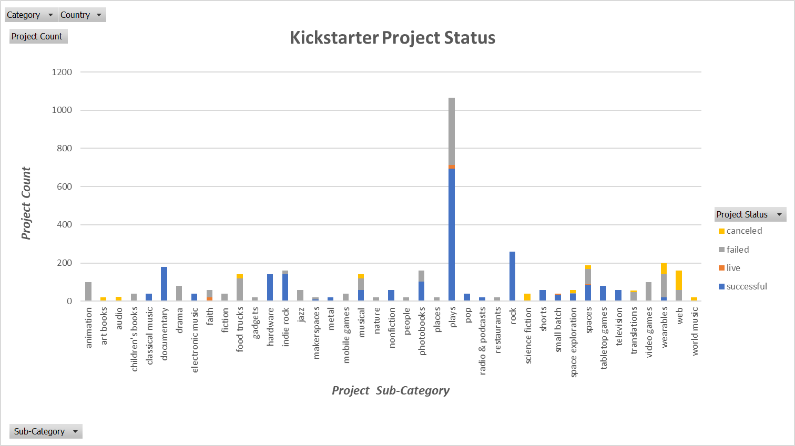

**Task.10 – Unix Date Conversion**

*Create a new column named `Date Created Conversion` that will the formula provided at* [*http://spreadsheetpage.com/index.php/tip/converting_unix_timestamps*](http://spreadsheetpage.com/index.php/tip/converting_unix_timestamps) *to convert the data contained within `launched_at` into Excel's Date format.*

*Then create another column titled `Date Ended Conversion` that will uses the formula to convert the data contained within `deadline` into Excel's Date format*

**<10> Task – Unix Conversion Notes:**

* **Unix time is defined as #/secs since midnight in Greenich, UK (GMT time) on January 1, 1970; to convert into an Excel date/time, take the following steps:**

1. **Convert seconds to days | =(((A1/60)/60)/24)**
2. **Add to date value for 1/1/1970 | =(((A1/60)/60)/24)+DATE(1970,1,1)**
3. **Adjust for GMT offset. Example NYC as -5 from GMT, CST is one hour earlier so s/b -6**
   * **CST offset is -6. | =(((A1/60)/60)/24)+DATE(1970,1,1)+(-6/24)**
     + **Simpler (but harder to see logic) formula is = (A1/86400)+25569+(-6/24)**
     + **I used this shorter formula for the sake of time**

* **Date Created or “Launched at” range from 2009 to 2017**

**Task.11 – Pivot Table Dates**

*Create a new sheet with a pivot table with a column of `state`, rows of `Date Created Conversion`, values based on the count of `state`, and filters based on `parent category` and `Years`.*

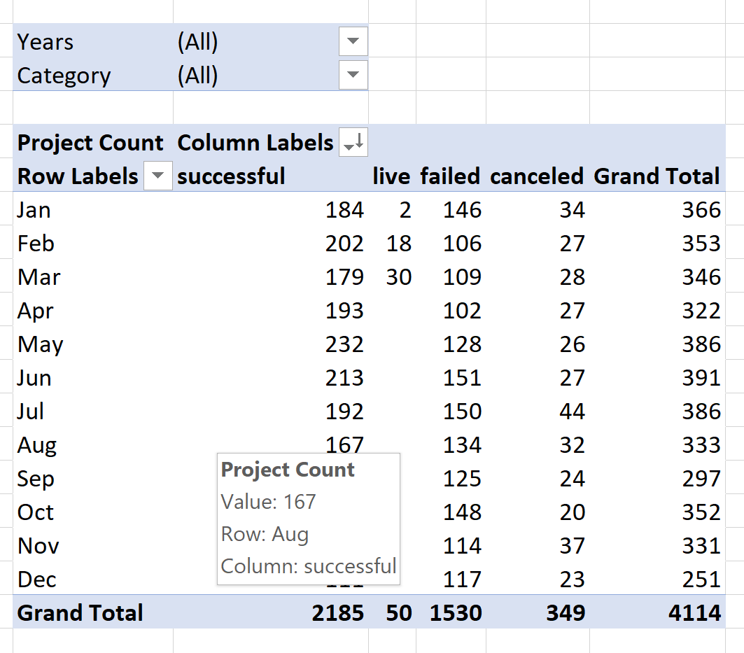

**Task.14 – Pivot Chart Line Graph**

*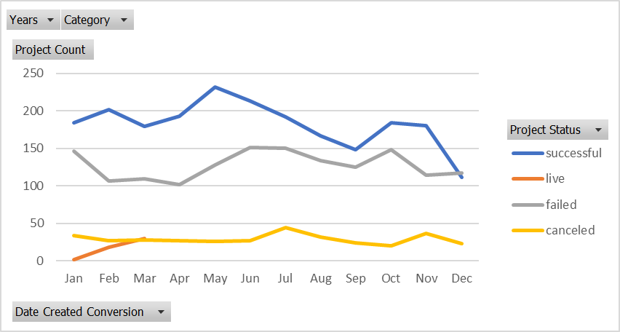Now* *create a pivot chart line graph that visualizes this new table.*

**Task.15 – Analysis Conclusions**

***Create a report in Microsoft Word and answer the following questions:***

1. What are 3 conclusions you can make about Kickstarter campaigns based on the data?
2. What are some of the limitations of this dataset?
3. What are some other possible tables/graphs that we could create?

*(See Word Doc titled “Conclusions_KickstartMyChart_Assign_MMielke” for responses)*

Extra Tasks

**Bonus.1 – Create New Worksheet**

*Create a new sheet with 8 columns: `Goal`, `Number Successful`, `Number Failed`, `Number Canceled`, `Total Projects`, `Percentage Successful`, `Percentage Failed`, and `Percentage Canceled`*

*In the `goal` column, create twelve rows with the following headers...*

* Less Than 1000

* 1000 to 4999

* 5000 to 9999

* 10000 to 14999

* 15000 to 19999

* 20000 to 24999

* 25000 to 29999

* 30000 to 34999

* 35000 to 39999

* 40000 to 44999

* 45000 to 49999

* Greater than or equal to 50000

**Bonus.2 – COUNTIFS Formula on ‘State’**

*Using the `COUNTIFS()` formula, count how many successful, failed, and canceled projects were created with goals within those ranges listed above. Populate the `Number Successful`, `Number Failed`, and `Number Canceled` columns with this data.*

**Bonus.3 – Sum and Percentage on ‘State’**

*Add up each of the values in the `Number Successful`, `Number Failed`, and `Number Canceled` columns to populate the `Total Projects` column. Then, using a mathematic formulae, find the percentage of projects which were successful, failed, or were canceled per goal range.*

**Bonus.4 – Line Chart on Goal relationship to ‘State’**

*Create a line chart which graphs the relationship between a goal's amount and its chances at success, failure, or cancellation.*